Automatically Populated Tearsheets

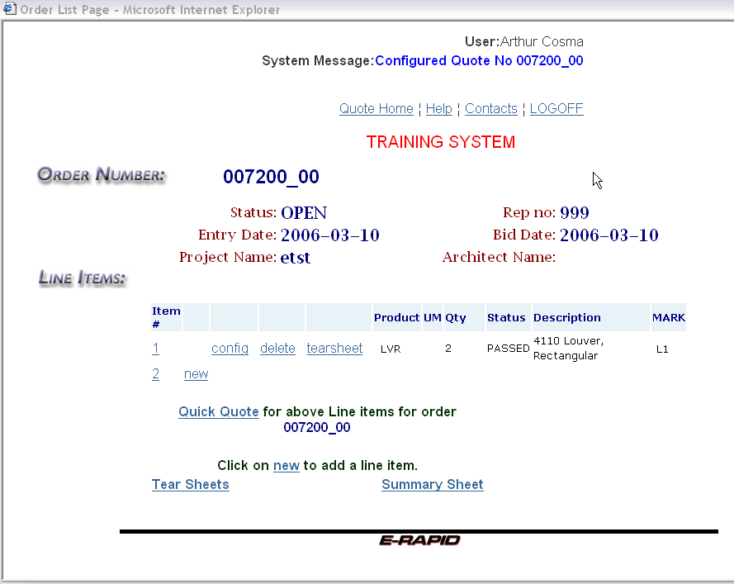

Clicking on the “TEAR SHEETS” at the lower left-hand side of the page will generate the tear sheets required for the entire project.

Clicking on the word “tearsheet” at the line level will pull up a tear sheet for that one line only.
Click on “TEAR SHEETS” at the lower left-hand side.
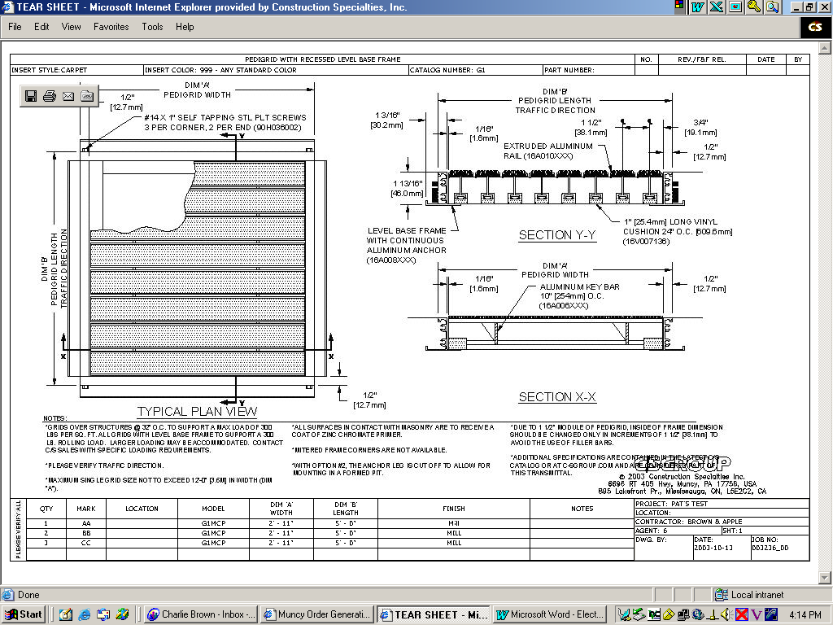

To print, click on “File” at the upper left.

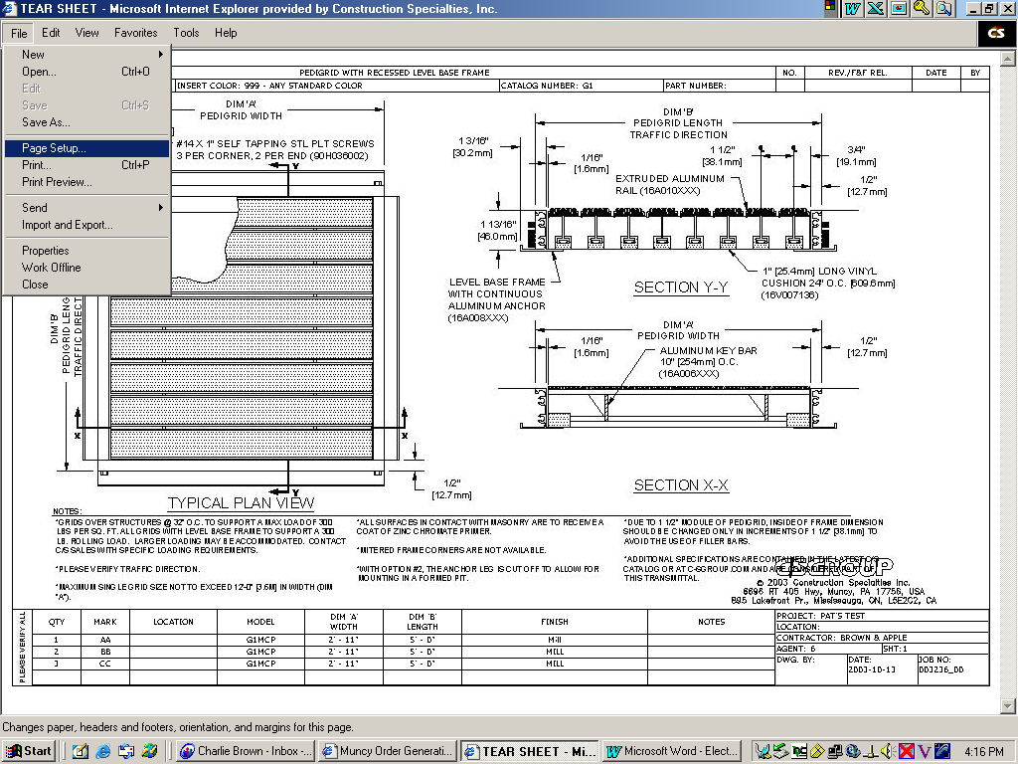
Click on “Page Setup.”
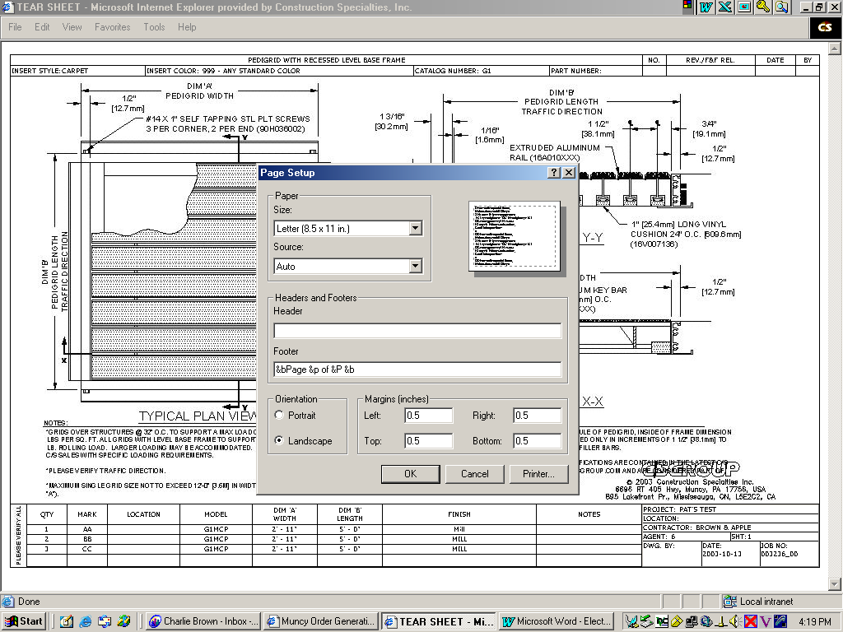

Change the Orientation to “Landscape.”

Margins at the bottom should be set to .25”.

Click on “Printer” at lower right of window.

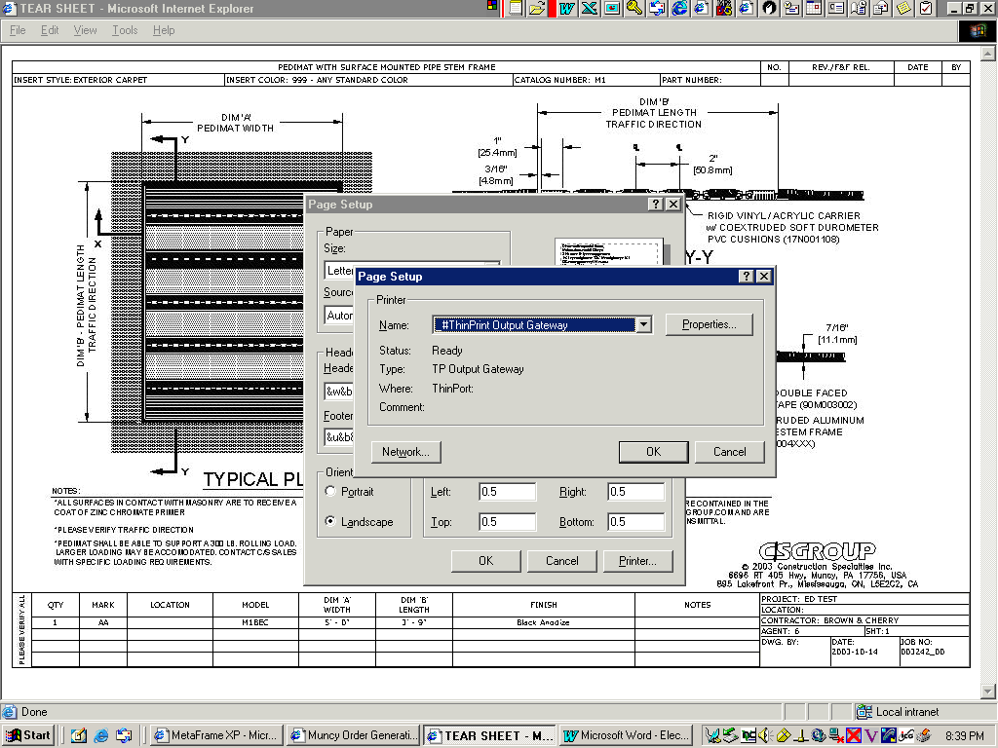
Printer name should be “#ThinPrint Output Gateway.”

Click the “OK” button on both pop-up windows.
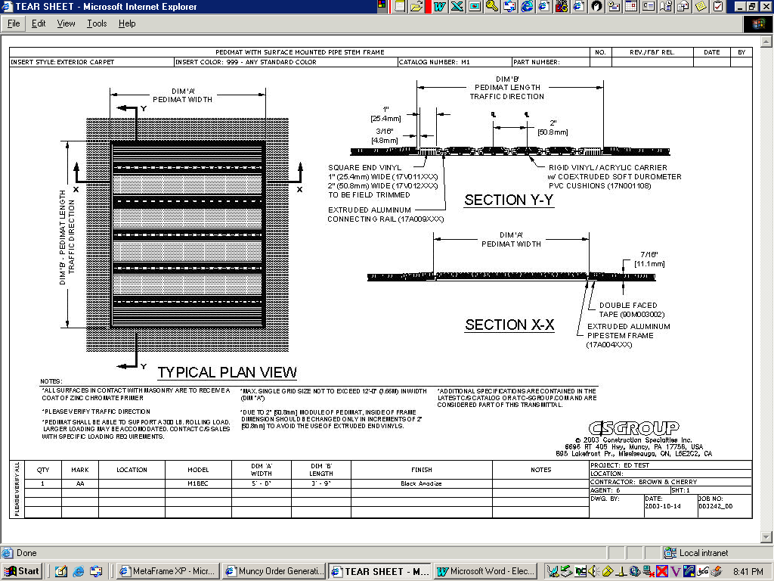

Click on “File”, and then select “Print.”

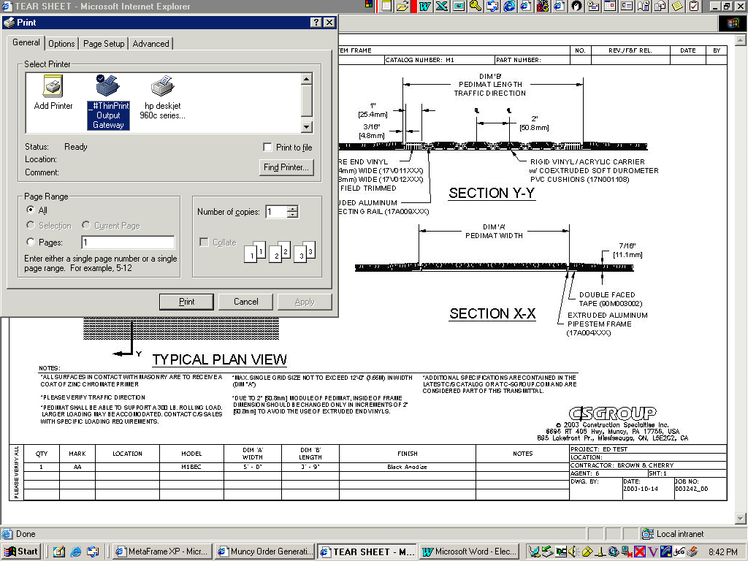

Click on the “Print” button.

End

